# Dannce GUI User Manual

If you launched the DANNCE GUI successfully, you should see this:

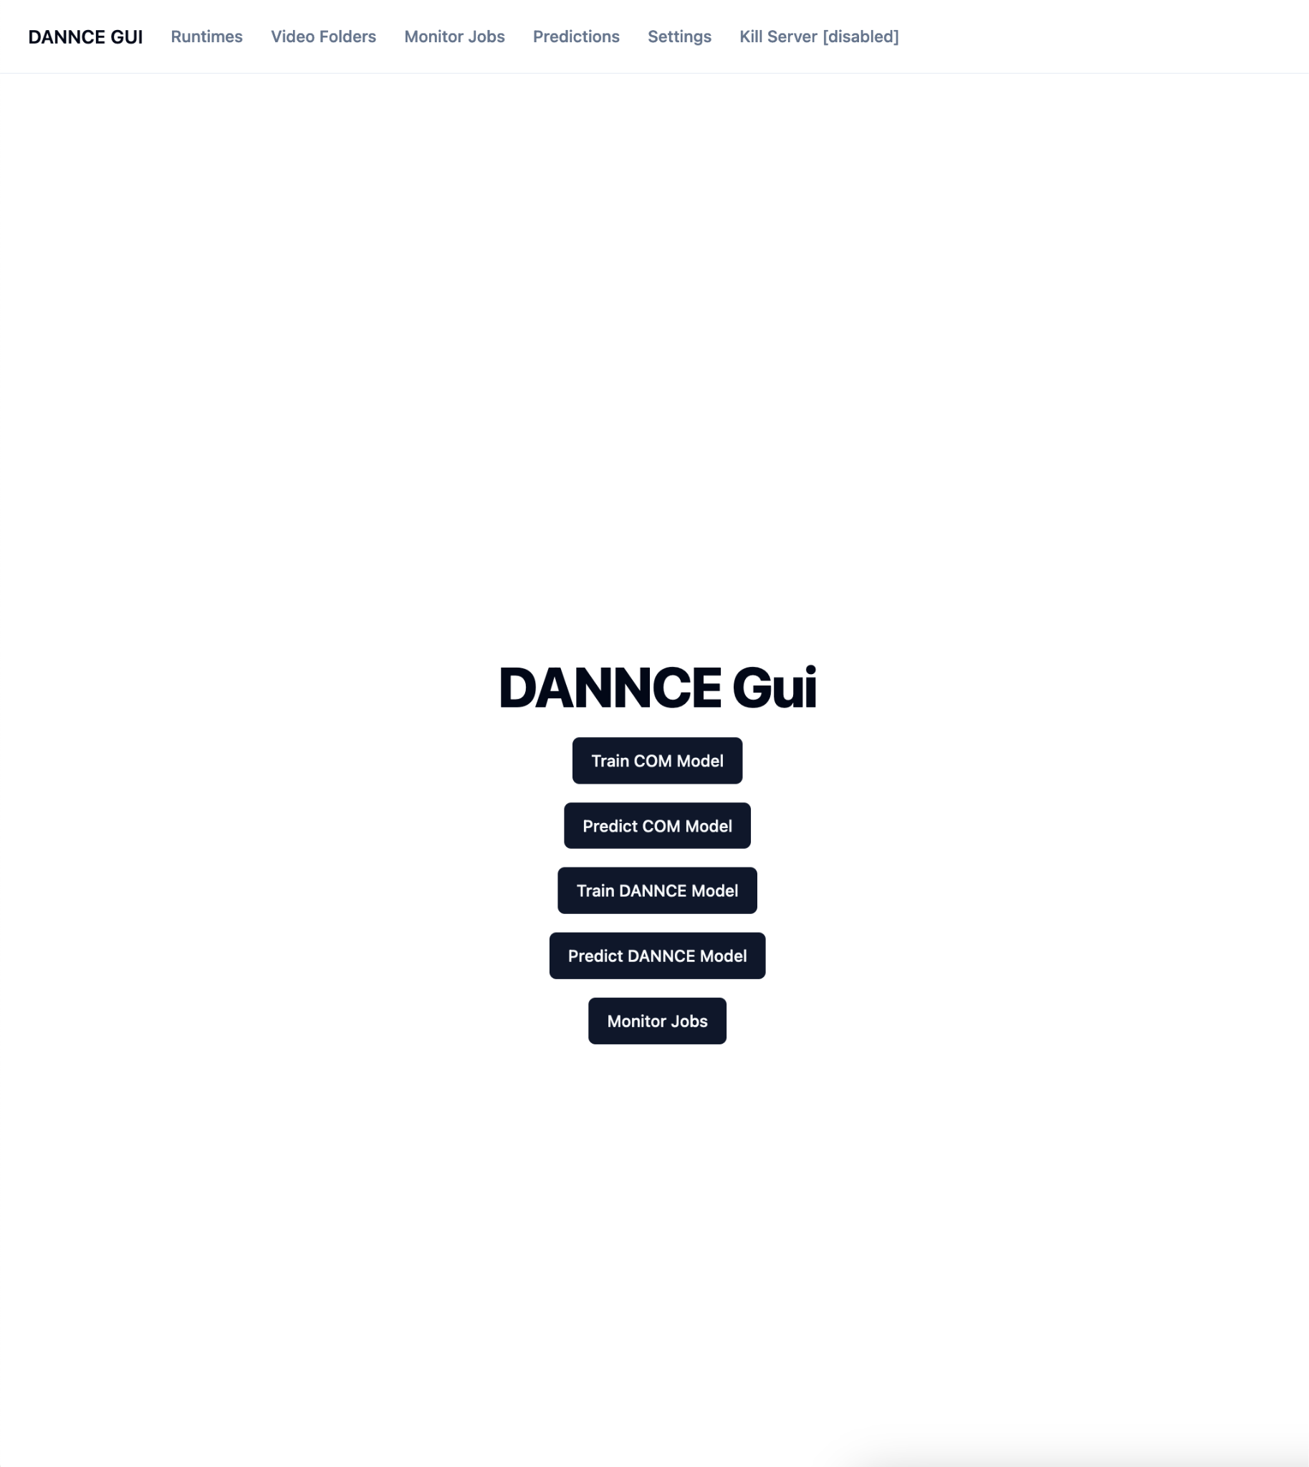

## Runtimes

The first step is to add a "Runtime", which is a description of the partition and resources on the cluster you will use to run your job. You have to do the first time you set up the dannce gui.

**Note**: you can create multiple runtimes to define different resources limits for different jobs. E.g. if you know your COM jobs require 30 GB of RAM and your DANNCE prediction jobs require 100 GB of RAM, you can create a different runtime for each, even with the same partition list.

You want to be conservative with the amount of resources you request, because you will be charged fairshare based on the amount of RAM and CPUs you request. Your job will be charged based on the runtime it uses (not max runtime entered), but specifying a larger max runtime may make your job slower to queue.

Also note: runtimes simply describe how to request resources from the slurm scheduler. Even if you only have one runtime specified, you can run multiple jobs at the same time on it if the scheduler has has the resources available.

Steps:

1. Click on the "Runtimes" header. You may see a list of runtimes, or an empty table. If you get a website error, it means there is an issue with your dannce gui setup.

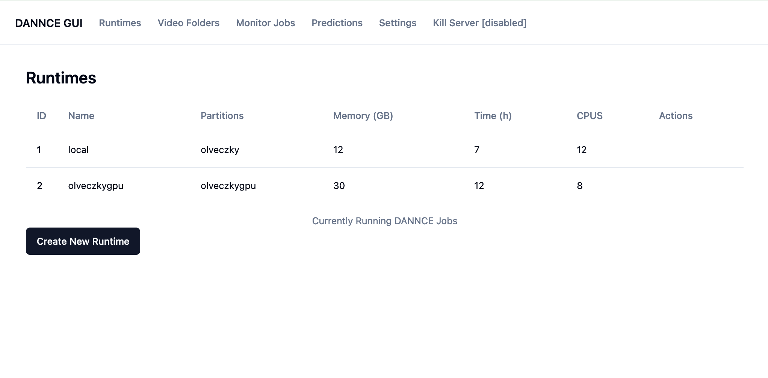

1. Click the "Create New Runtime" button at the bottom of the page. Enter the following fields:
   1. **Runtime Name**: a human-readable name for your runtime. You will use this to select a runtime from a list of runtimes. E.g. "gpu (low-mem)" or "olveczkylab".
   2. **List of SLURM partitions to use:** enter a single slurm partition where you will run your training/prediction jobs, or a list if there are multiple options. E.g. if you have a partition called "gpu" on you cluster, you can just enter *gpu*. If your job can run on any of the following partitions: "gpu" or "olveczkygpu" or "sharedgpu", you can enter these partition names separated by a comma (no space). E.g. *olveczkygpu,gpu,sharedgpu*
   3. **Memory to Allocate (GB):** enter how many of gigabytes RAM to use for running dannce jobs on this partition. E.g. 30. Must be a whole number.
   4. **Job Max Runtime (hrs):** maximum amount of time a job can use to run. If the job runs longer than this, it will be killed by the slurm queue manager. E.g. *12*. Must be a whole number.
   5. **# of CPU's to allocate:** Enter the number of CPU's your slurm job will be allocated to run DANNCE jobs. Must be a whole number. Since dannce train/predict jobs mostly run on the GPU, you do not need a large number of CPUs. 8 is probably plenty. E.g. *8*

Here is an example of a filled-out runtime.

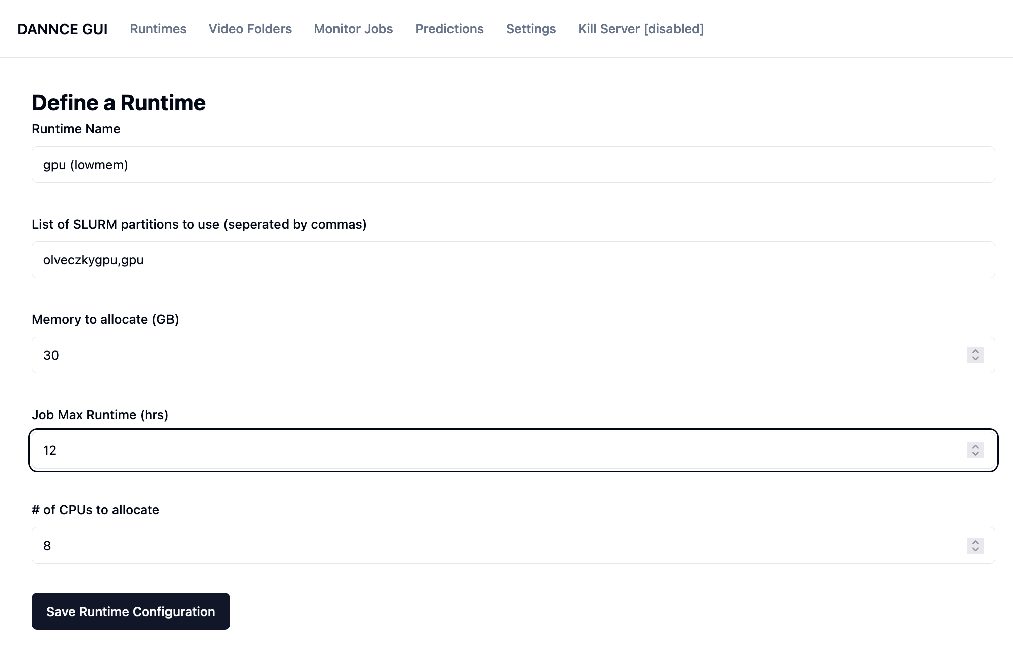

1. Click Save Runtime Configuration to create the runtime.
2. (optionally) create multiple runtimes for different situations

CURRENTLY, you cannot modify created runtimes, so if you have to change something, you need to create a new runtime.

## Video Folders

Now that you have added a runtime, you can import video folders the the DANNCE GUI.

It is necessary to import video folder(s) before using those videos for dannce training or inference with the GUI. This will **copy** all the video files, so be aware this can make the dannce instance folder 10's or 100's of GBs in size.

**Tech detail**: The importing step may also reencode or otherwise process the video file. Currently, the video folder adds the mp4 faststart flag, which makes it possible to stream the videos in the browser.

How to import video folders:

1. Click on the "Video Folder" line in the header.
2. You should see a table which may be empty.

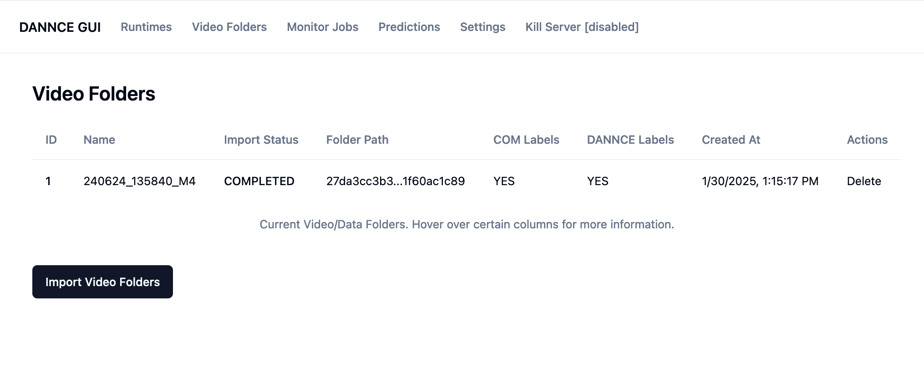

1. Click "Import Video Folders" button, this will take you to another page where you can enter video folder paths:

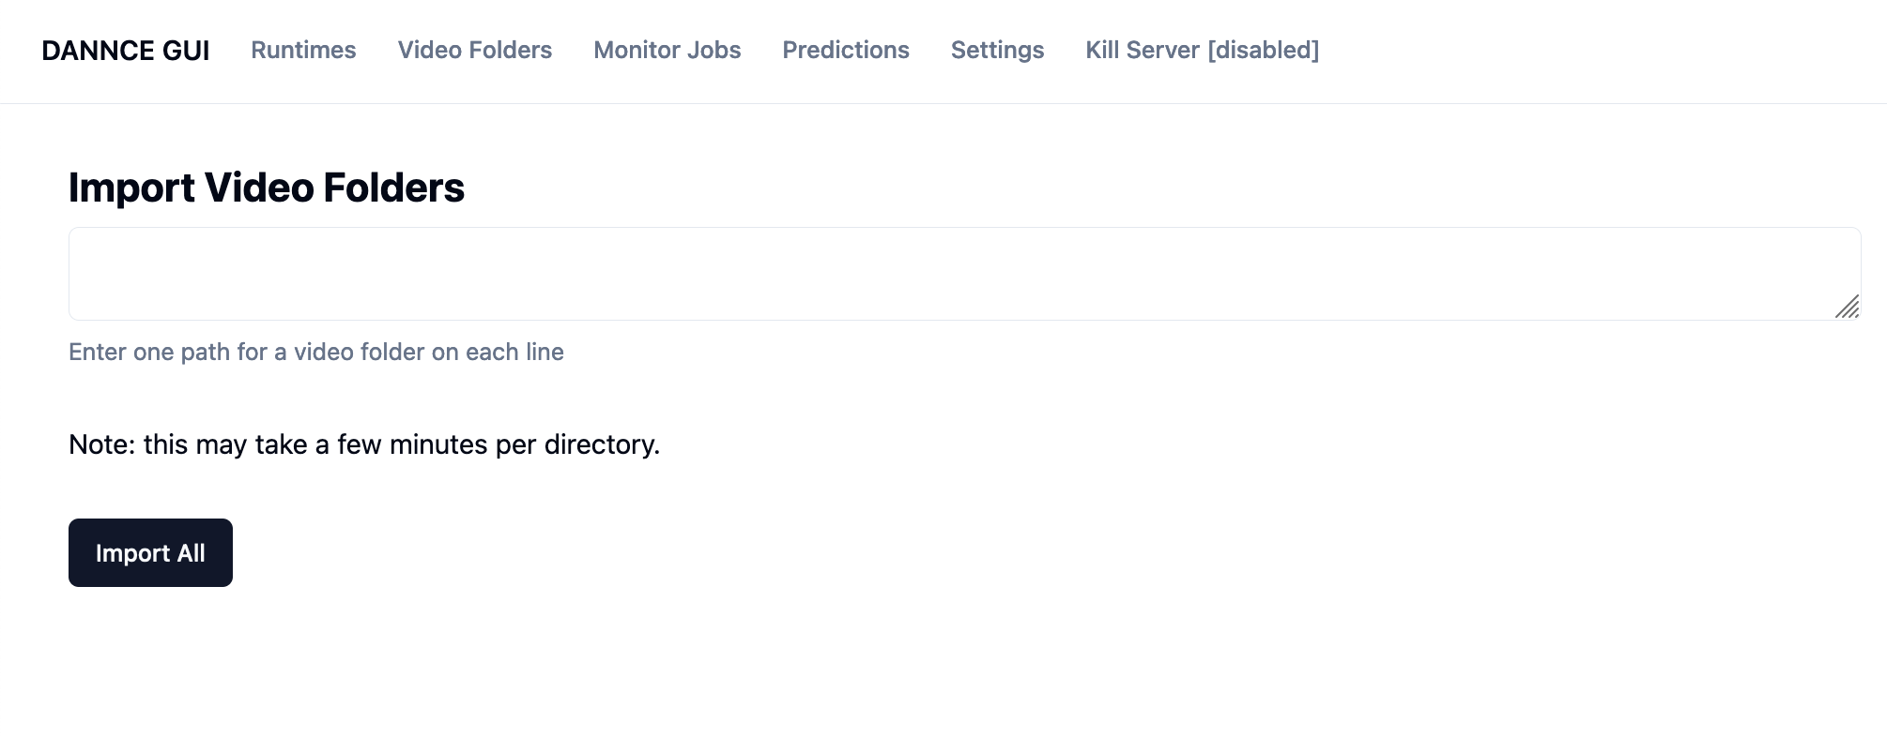

1. On this page, you can enter a list of video folder paths you would like to import, separated by a newline. **What is a "video folder"?** A "video folder" is expected to have the following structure:
   1. Subfolder called "videos" with one folder per camera, and a file 0.mp4 in each camera folder
   2. Contains some form of calibration data. This may be a *dannce.mat file at the root directory or a subfolder called "calibration" with Hires_camX.mat files.

E.g. I might import the following lines:

/n/olveczky_lab_tier1/Lab/dannce_rig2/data/M1-M7_photometry/Alone/Round_1/Day1_wk2/240624_135840_M4

/n/olveczky_lab_tier1/Lab/dannce_rig2/data/M1-M7_photometry/Alone/Round_1/Day1_wk2/240624_135840_M5

1. Finally, click: "Import All", and the page should redirect to the "video folders" page
2. Each folder you listed should appear as a row in the table. The import status should say "PENDING" or "PROCESSING" for each row
3. Wait about 1-5 minutes per video folder for the importing to take place. Refresh the page occasionally.
4. Finally, when each of rows has an import status of "Completed" this means the import was successful.

You can click on a the video folder name in the table to go to the video folder details page.

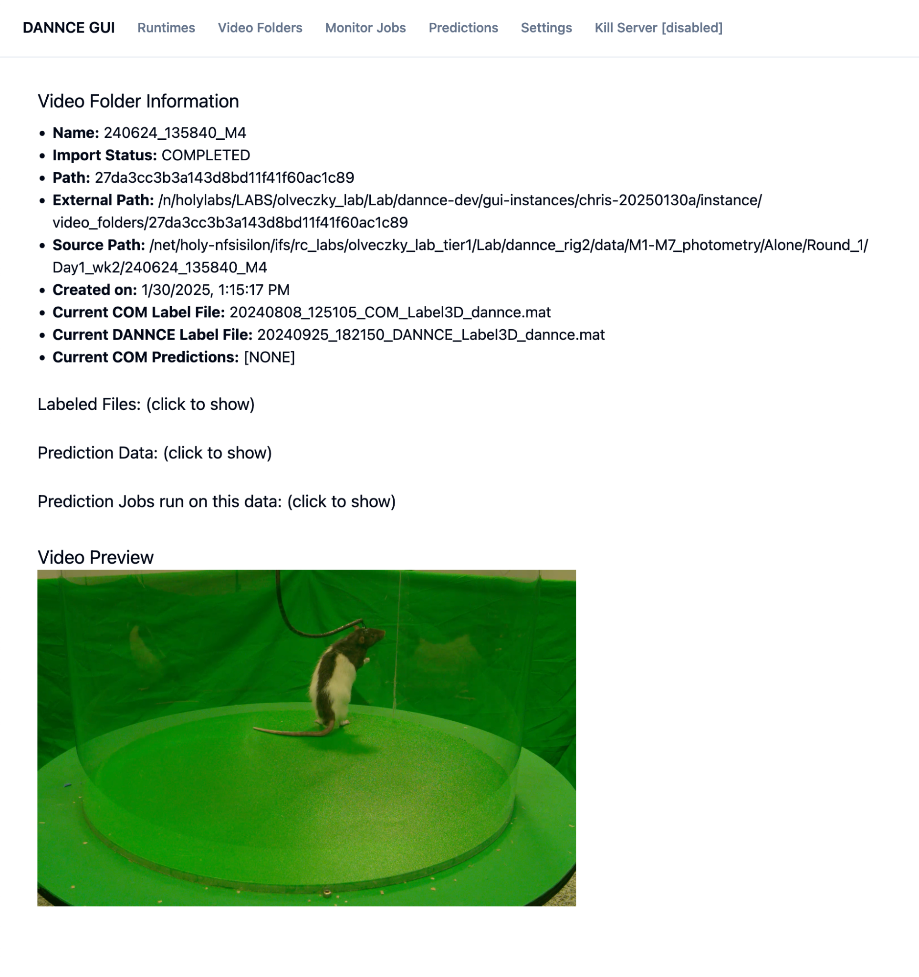

This page lists information such as:

* Source directory where the video folder was imported from (source path)
* Path on the host machine where the imported video folder lives (external path)
* Date and time the folder was imported (Created on)
* If any COM or DANNCE.mat files were detected during import
* If any prediction data was detected during import (click on "prediction data" to show)

NOTE: the "Current COM Label file" and "Current DANNCE Label file" are chosen by picking the most recent COM and DANNCE label file in the directory. These will be used for training.

You can also click on "Show Video Preview" to stream the video folder from a single camera.

## Submit Training Jobs

Click on "DANNCE GUI" in the top left of the header to get to the home page.

**Submit COM Training:**

From this page, you can click "Train Com Model" to go to the Com Training Job page

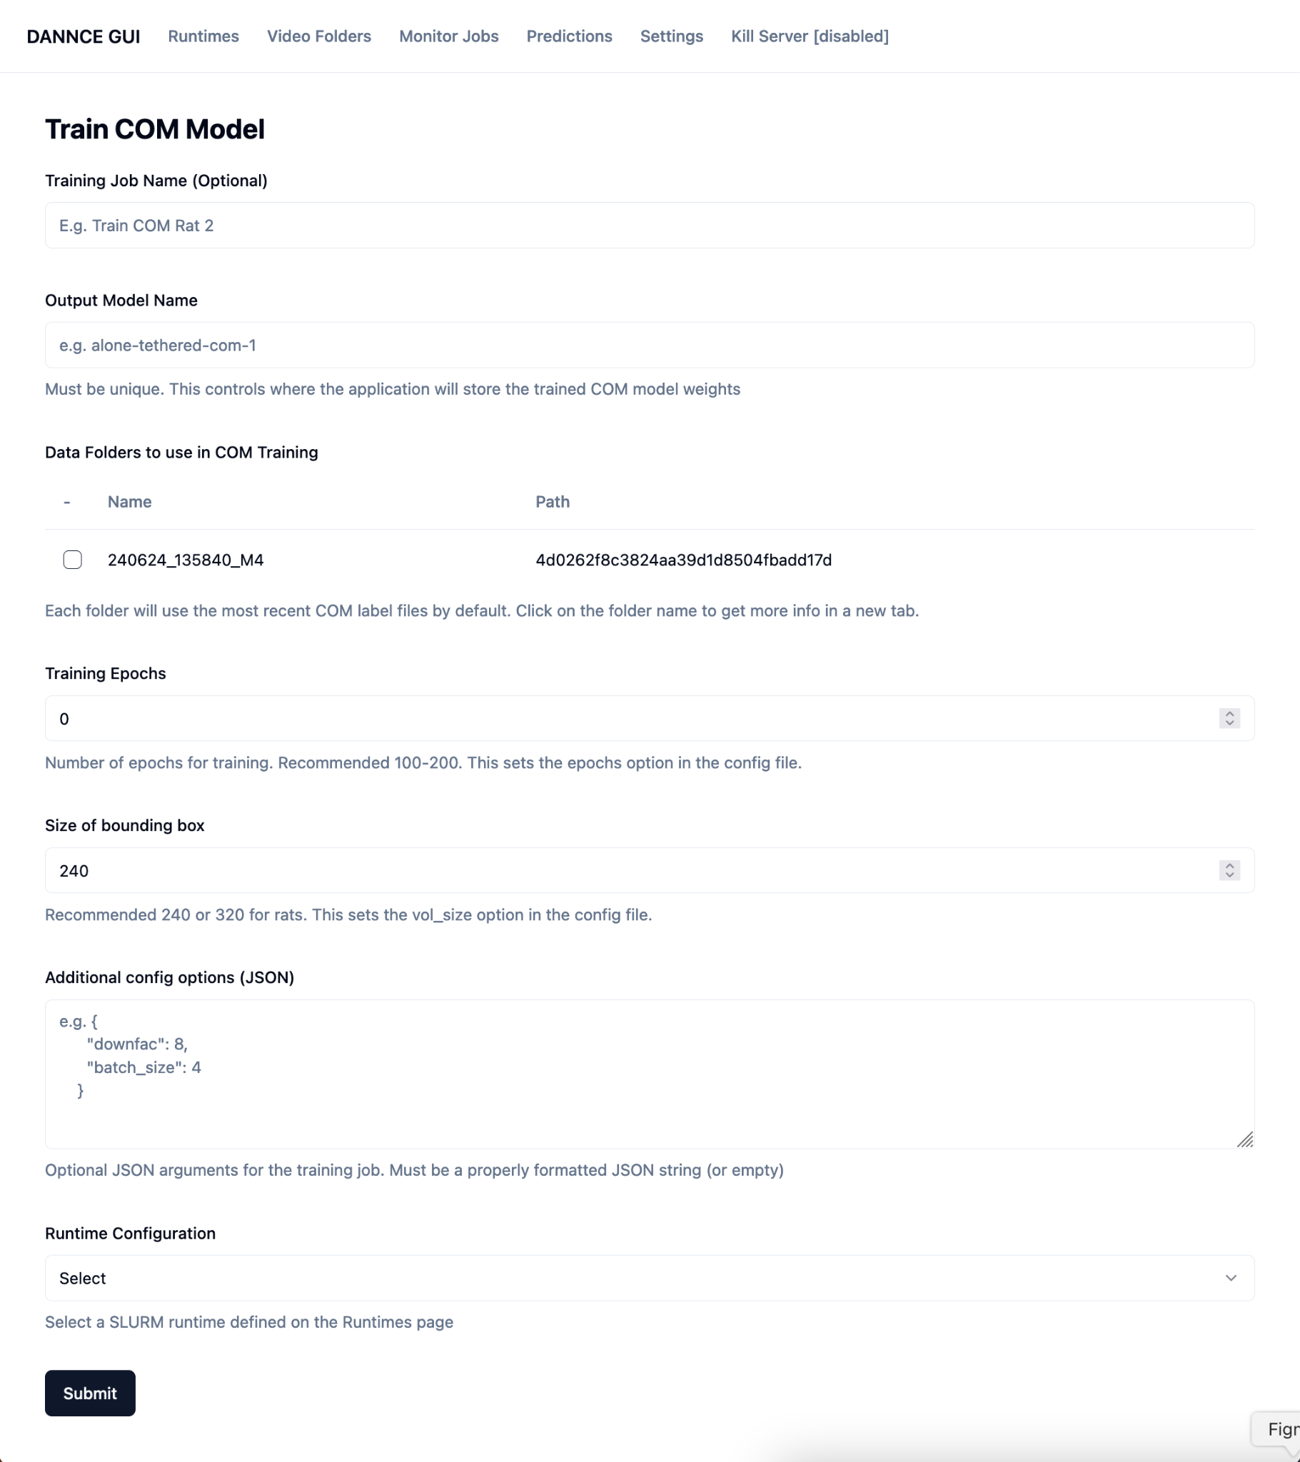.

Enter the following fields:

1. **Training Job Name**: this is an optional field which will give the training job a name. The name is to help the user identify which training job is which, and will show up in Slurm as the job name.
2. **Output Model Name**: this name will help you identify the model weights generated during training. I would give it a useful name: e.g. *M4-120epochs*.
3. **Data folders to use in COM training**: this is where you select all video folders you want to pull in for com training. Only video folders which have completely imported and which have a "current COM label file" will show up here, since it uses the "Current COM label file" to as labeled training data. Select the checkbox next to each folder you wish to include. You can include more than one video folder in COM training.
4. **Training Epochs**: enter the number of epochs. Recommended 100-200, but this depends on your how much training data, and other parameters. E.g. *100*.
5. **Size of Bounding Box**. This sets the size of the bounding box which. If keypoints are being clipped when the animal is fully extended, try increasing this numer. Recommended 240 or 320 for rats, and can be smaller for mice.
6. **Additional config options (JSON):** Optional field. If provided, this field must be a valid json string. Here, you can specify parameters which will be used to configure the COM or DANNCE training.
7. **Runtime Configuration:** select which runtime will be used to submit the COM Training

Once all the fields are filled out, click "Submit" and the browser should redirect to the "Monitor Jobs" page.

**Submit DANNCE Training Job**

Follow the same steps as for a COM training job. Note, the video folders available must have both 1) COM predictions generated from running COM Predict and 2) a "Current DANNCE Label File" specified.

## Submit Prediction Jobs

Click on "DANNCE GUI" in the top left of the header to get to the home page.

**Submit COM Predictions Job:**

From this page, you can click "Predict Com Model" to go to the Predict COM Data page.

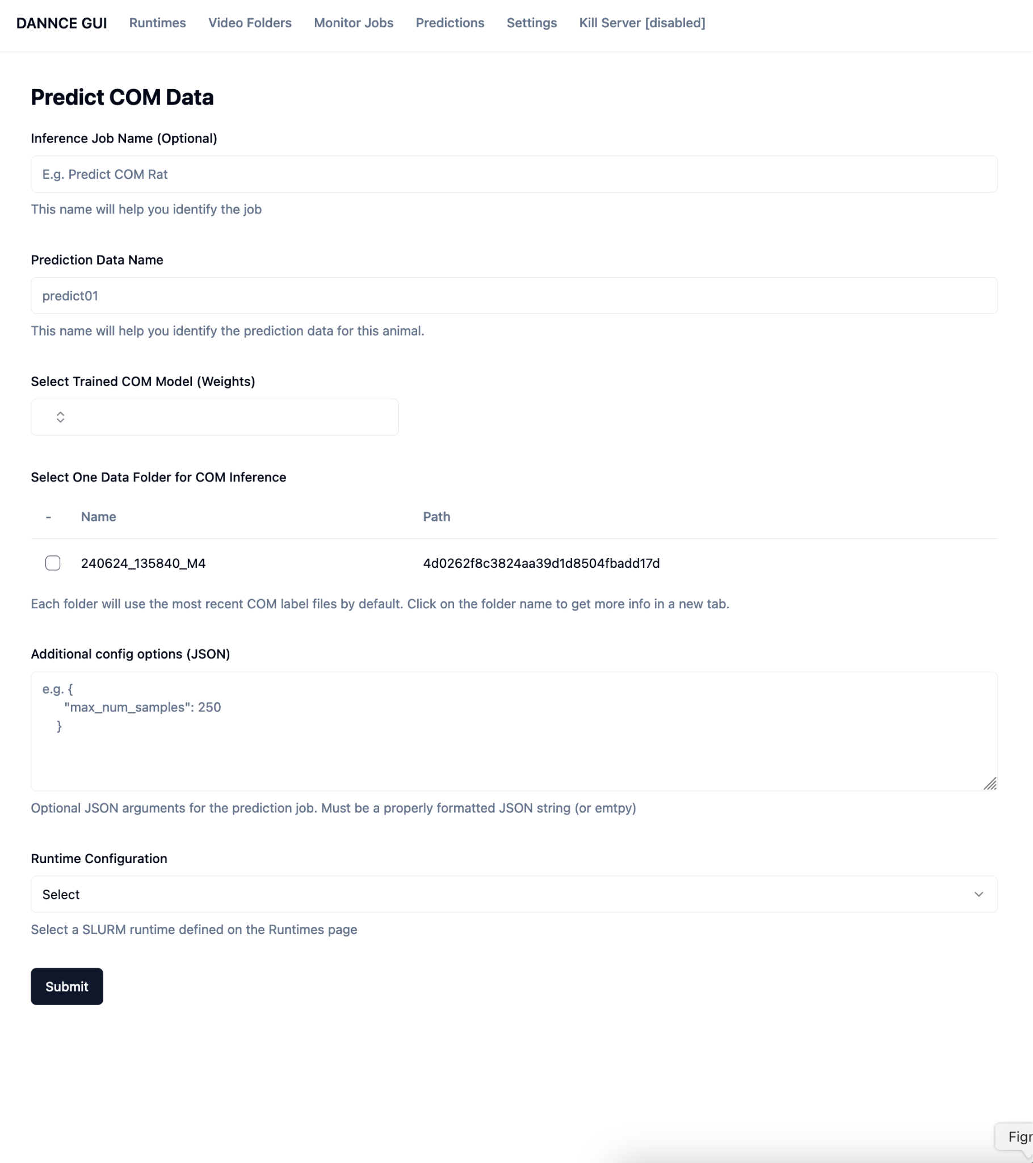

Enter the following fields:

1. **Inference Job Name:** This name will make it easier to locate the prediction job on the Monitor Jobs table. This name will also be used by slurm when submitting a job. Optional, but recommended.
2. **Prediction Data Name**: This name will help you identify the specific COM prediction. Use a descriptive name e.g. *M4_weights*
3. **Select Trained COM Model (Weights):** From the dropdown, select a previously trained COM model. If there are no COM models listed, you must submit a Train COM job and wait for it to complete.
4. **Select One Data folder for COM inference**: Select a video folder to have COM predictions generated for each frame in the videos. You can only select one video folder per Predict Job, but you can submit multiple predict jobs in parallel to predict across multiple video folders.
5. **Additional config options (JSON):** Optional field. If provided, this field must be a valid json string. Here, you can specify parameters which will be used to configure the COM or DANNCE training.
6. **Runtime Configuration:** select which runtime will be used to submit the COM Inference

Once all the fields are filled out, click "Submit" and the browser should redirect to the "Monitor Jobs" page.

**Submit DANNCE Predictions Job:**

Follow the same steps as for a COM predictions job. Note, the video folders available must have COM predictions generated from running COM Predict.

## Monitor Jobs

Click on "Monitor Jobs" in the header

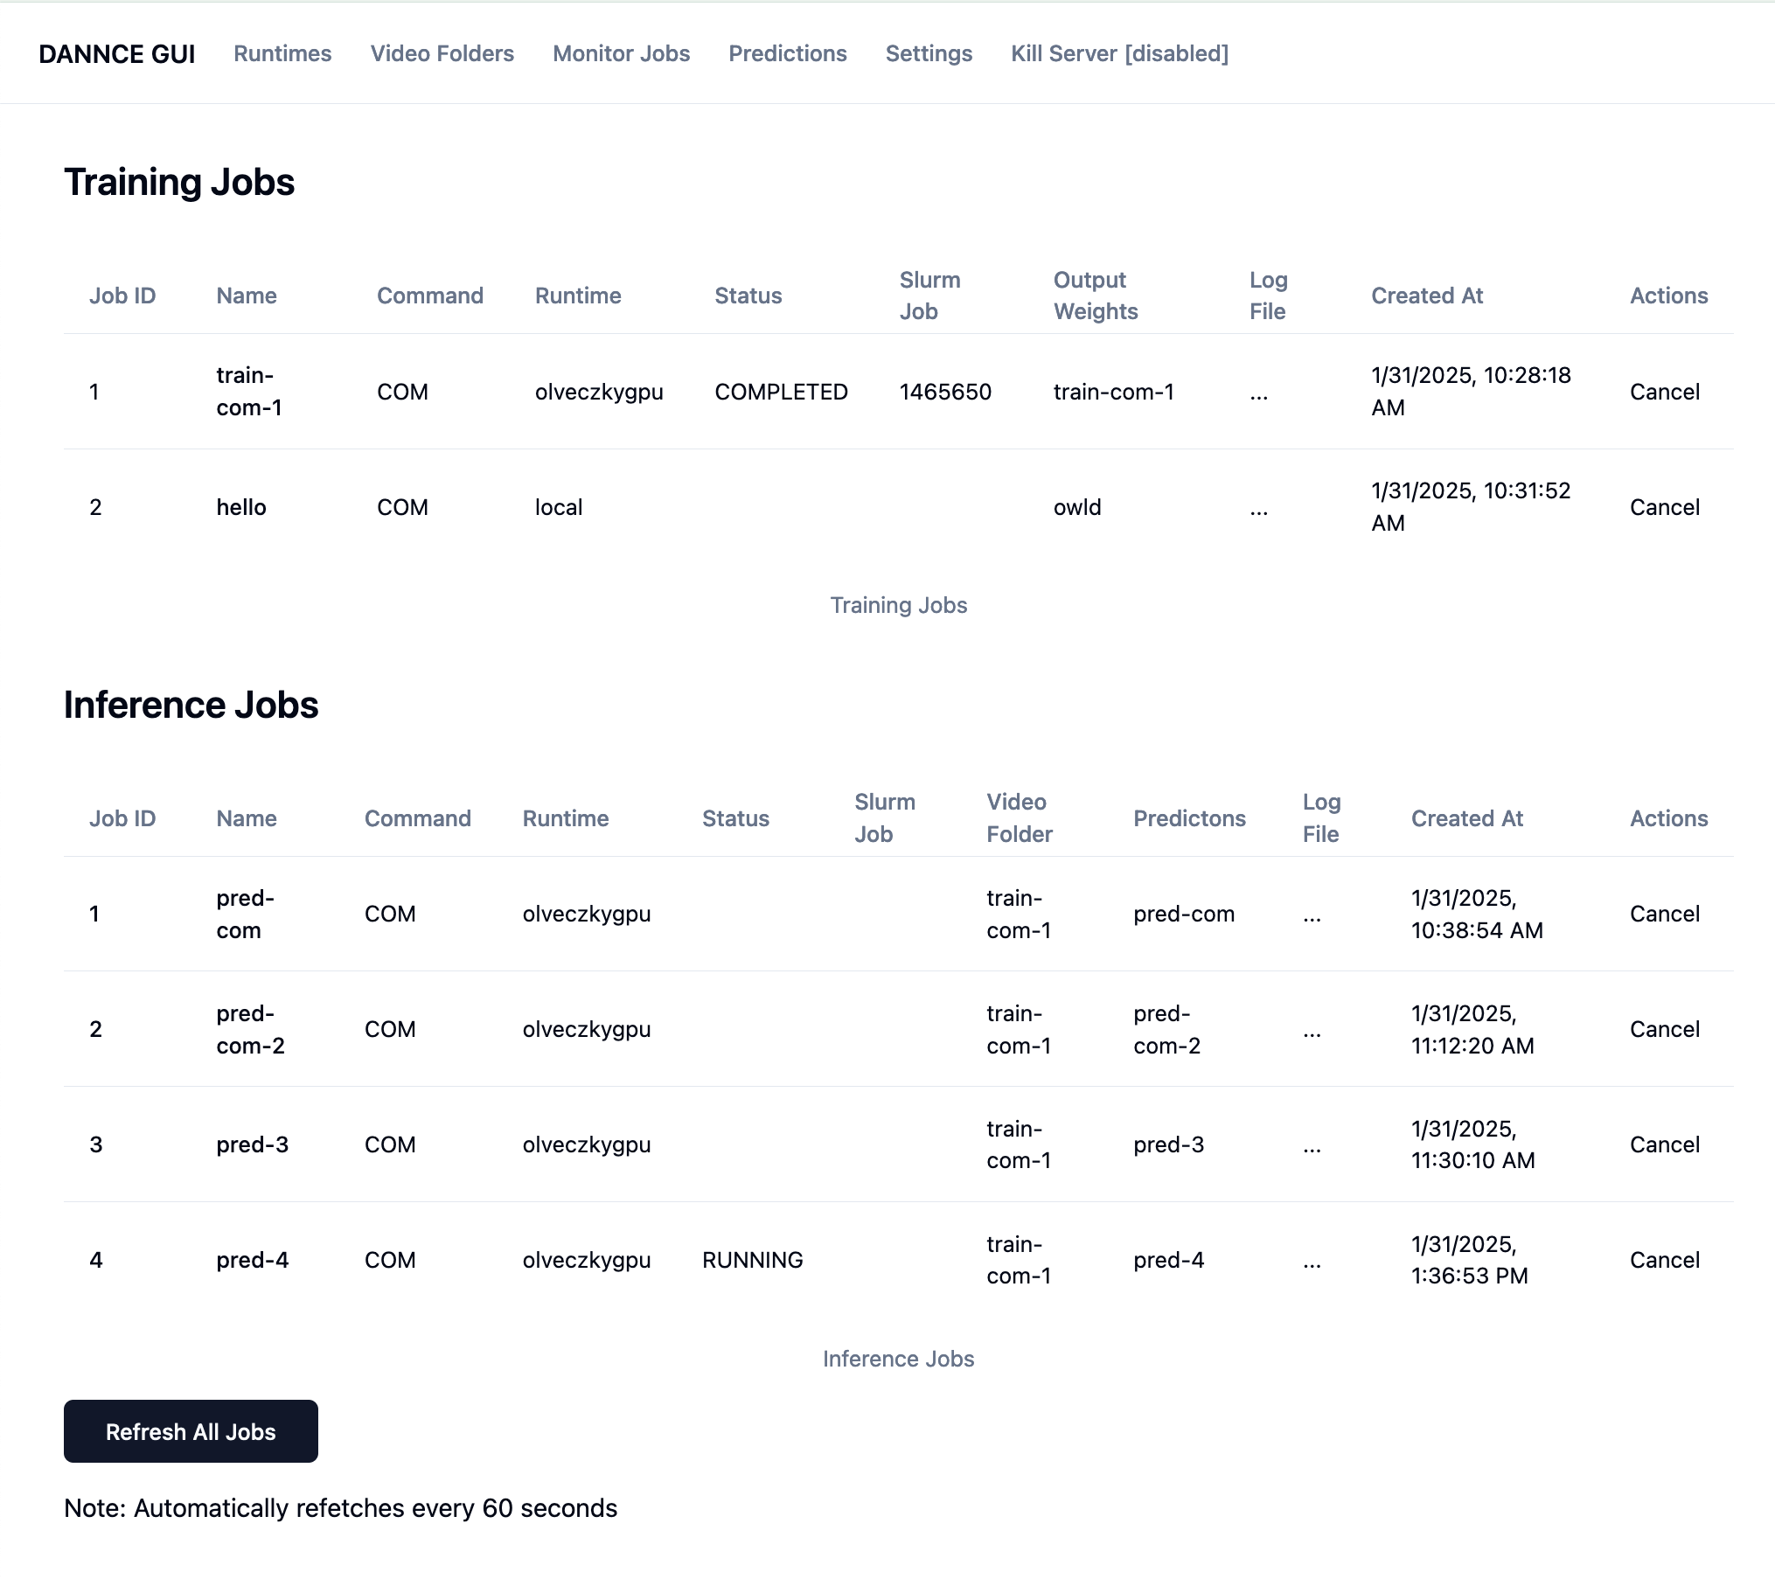

Here, you can view an overview of all training or inference (prediction) jobs you have submitted. This list queries the slurm jobs table every 6 minutes by default. However, you can ask it to refresh immediately by clicking "Refresh all jobs".

Once a job is finiehd running the status will change to "COMPLETED".

You can click on a job name to be taken to job details page to view job logs.

## Job Details Page

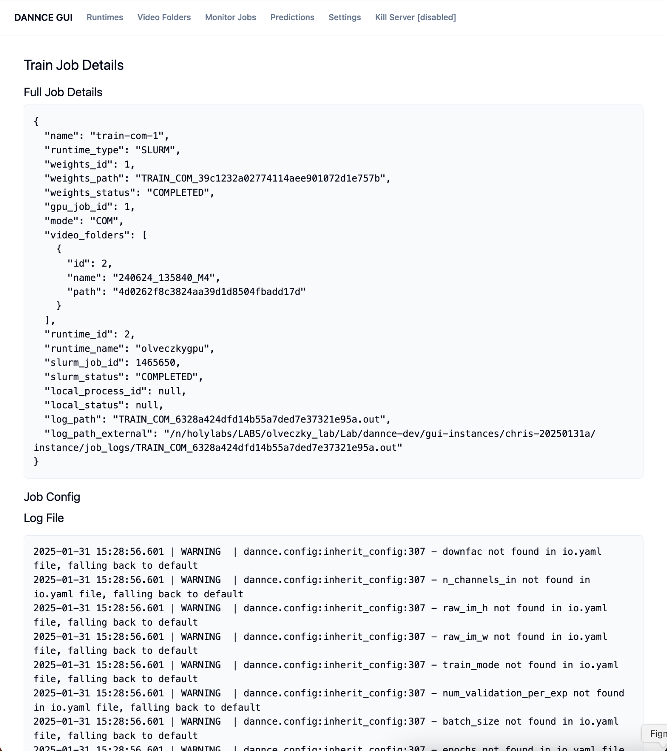

Here you can see details about a running job. If you scroll past Job Config, you can see the job log from slurm. Scroll down to the bottom of the textbox to see the most recent log entries.

If the log text does not appear, it is possible the job has not started running, and so the stdout file has not been created yet.

## Predictions

If you click on the "Predictions" button in the header, you will be directed to the predictions page.

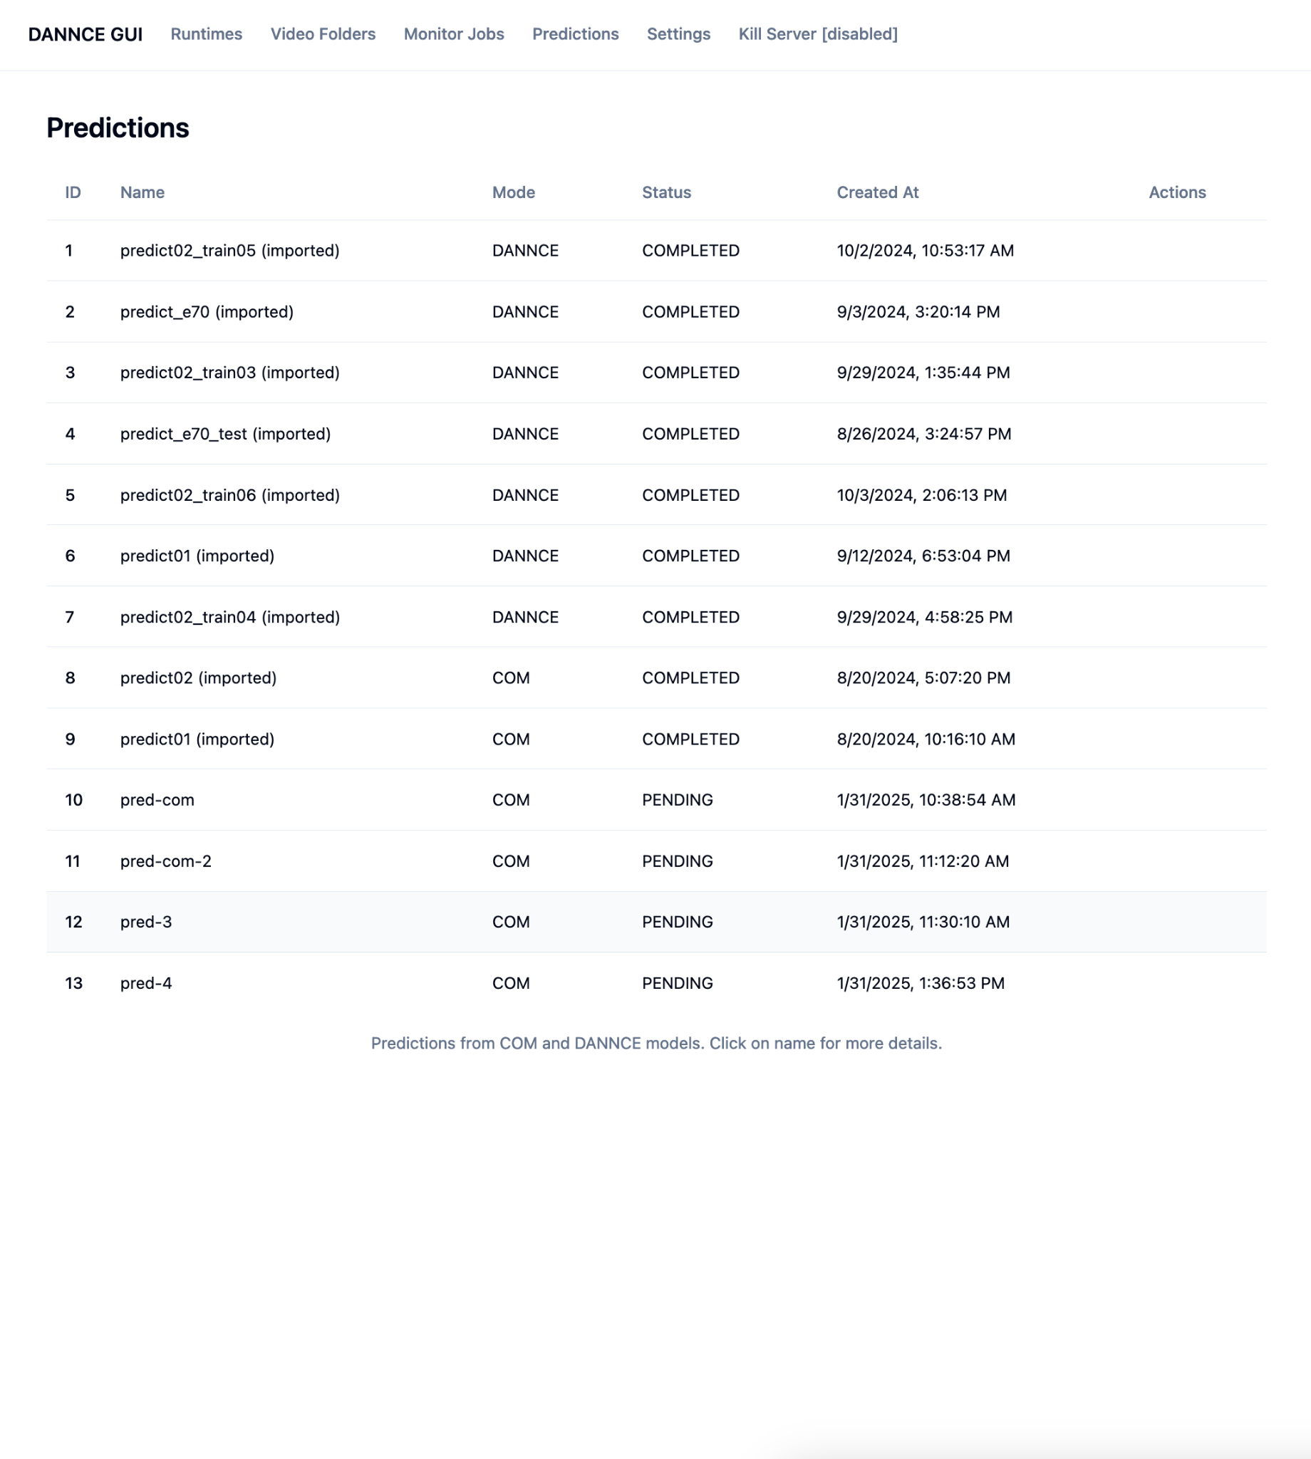

Here you can see all generated predictions. This includes "COM" predictions, which has a single COM 3d keypoint for each frame in the video; and "DANNCE" predictions which have a number of keypoints for each frame (e.g. 23).

Click on a prediction name for more information. If a prediction name is followed by "(imported)", this prediction was located in the video folder when you ran import video folders; otherwise the prediction was generated by running COM/DANNCE predict from within the DANNCE GUI.

DANNCE predictions will look like this:

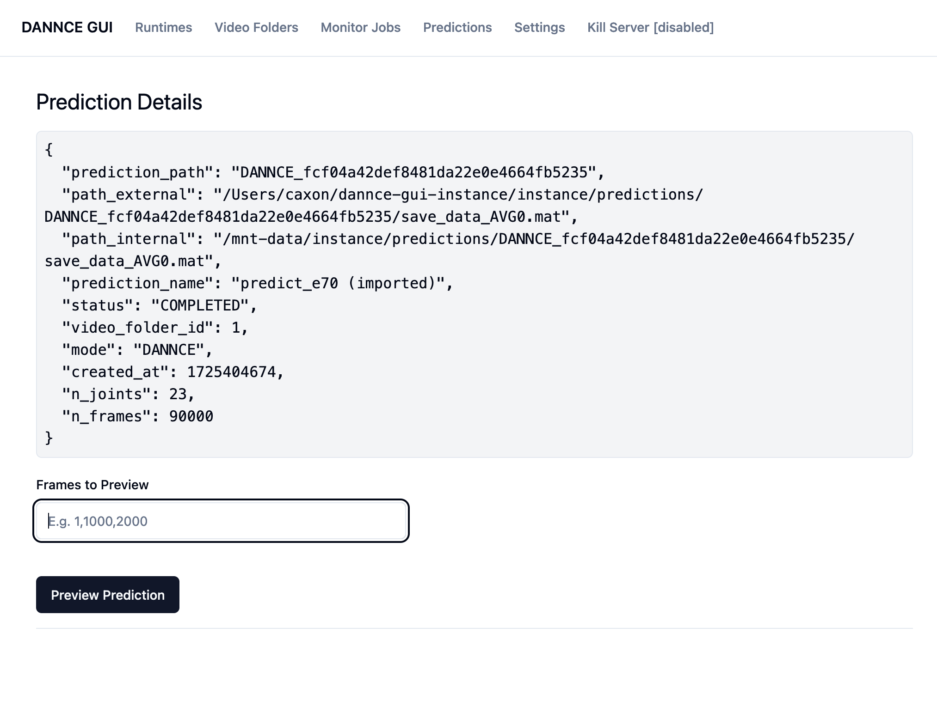

COM Predictions will have a few more buttons:

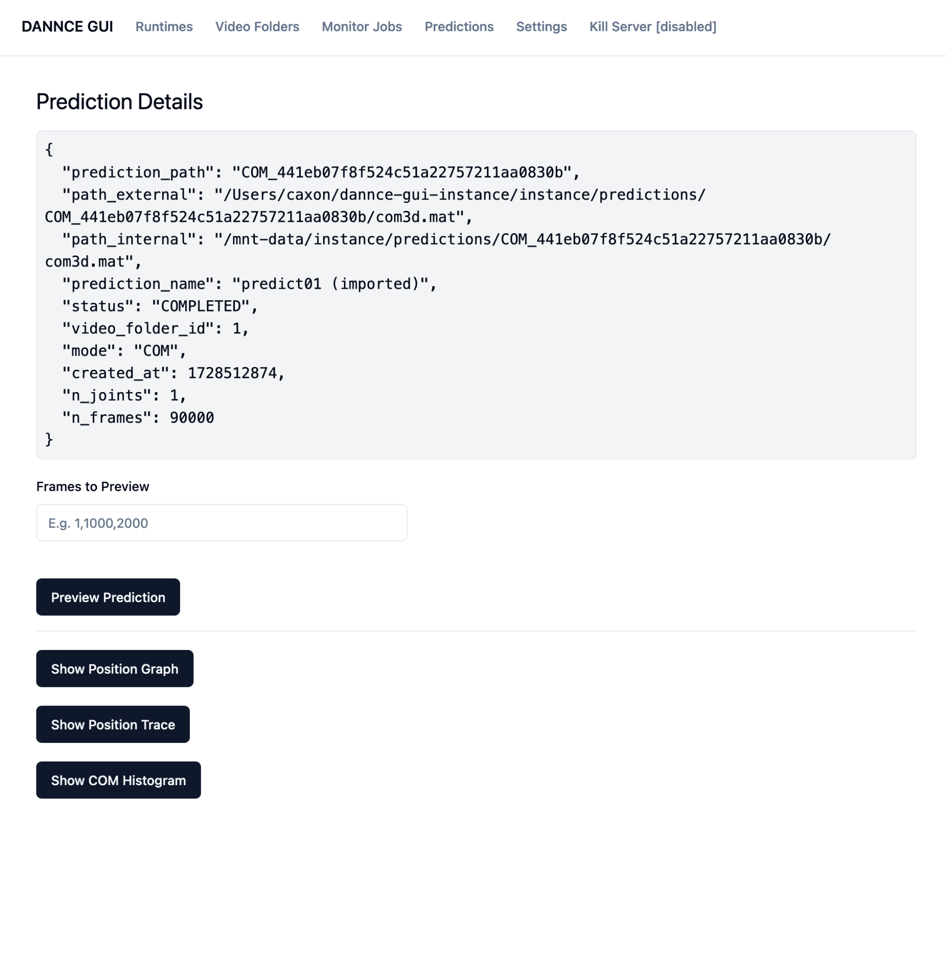

You can view a small number of frames by entering a list of integer frame numbers, separated by commas, in the Frames To Preview input: e.g. 1,10000,20000,30000

These numbers **cannot be less than zero, and cannot be >= the number of frames in the prediction (see n_frames in Prediction Details)**. You can also list at most 10 frames to preview.

After entering a set of frame numbers, click "Preview Prediction" and the DANNCE GUI server will extract these frame numbers from the video folder, and show the keypoints as pink dots:

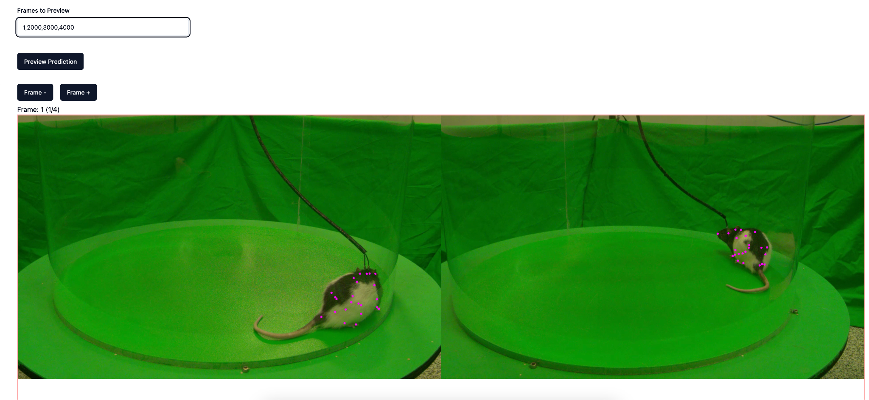

If you would like to see the skeleton joint connections (highly recommended), click on the "Settings" header, and then select Browse. From here you can pick a .mat file containing skeleton data. This should be the skeleton used during labeling, and there should be several of them in the Label3d "skeletons" folder. E.g. rat23.mat. Click "Use this skeleton" to upload the file.

If you return to the preview prediction page after selecting a skeleton, you should see something like this:

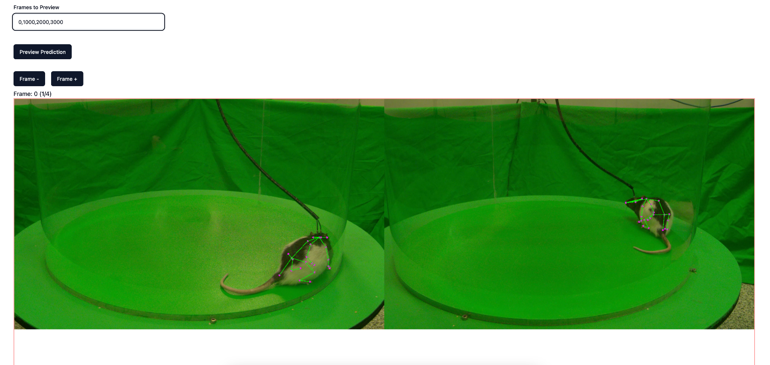

If you are viewing a COM prediction, there are a few extra visualization tools to help you decide if a COM prediction is good.

**Position graph:**

First, there is a **position graph** which tracks the COM prediction over the entire recording. The y-axis tracks X,Y, and Z coordinates in mm from an origin point (the origin point is determined during camera calibration). The x-axis is the frame number of the recording. In this case, the video recording is 50 FPS (frame per second), so the x-axis goes from time=0 to time=30 minutes.

Furthermore, you can click on the x, y, or z text in the legend beneath the graph to hide the other two lines, to make it easier to focus on a single line. Click on the same text again to reveal all of the lines again.

This graph is useful for visualizing any abnormally large spikes in X, Y, or Z positon.

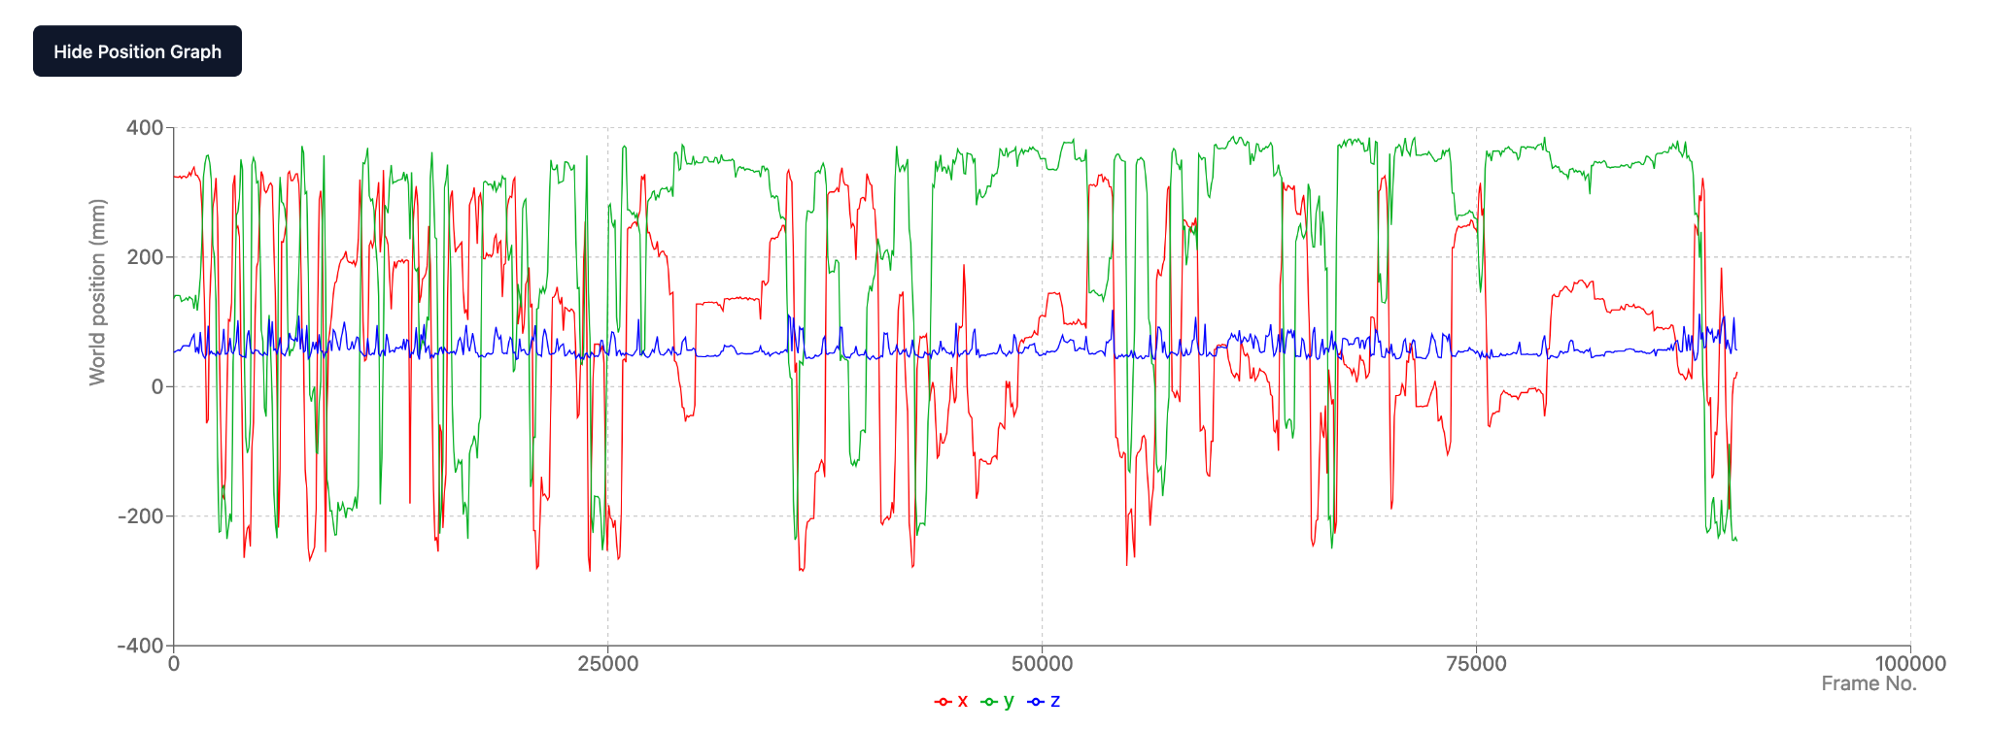

**Position Trace:**

This graph show the x and y position of the COM keypoint on the animal across all frames in the recording. The pink line is the entire path of the mouse, and is always visible. The grey line is drawn as the rodent moves across the stage in the prediction timeline (sped up).

This graph helps you verify COM recordings by making sure the COM trace stays within the arena.

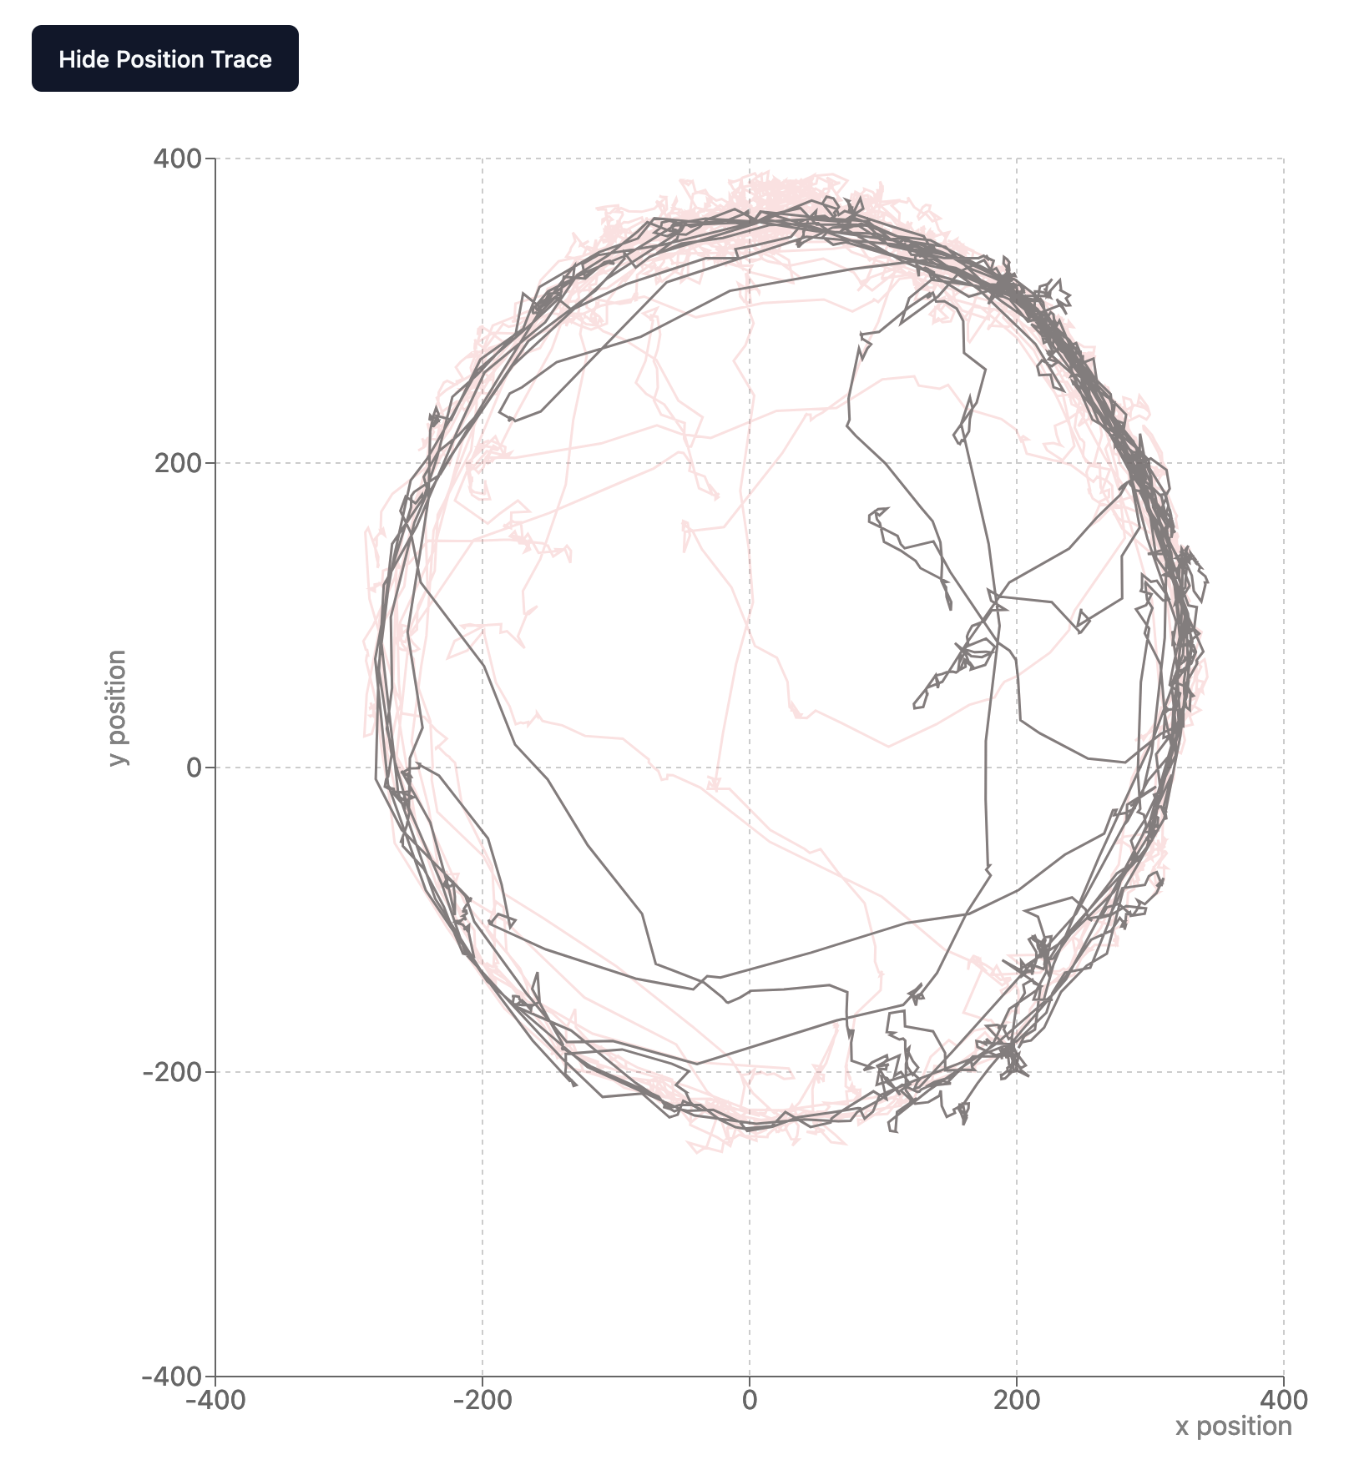

**COM Histogram:**

Finally, this graph shows the distance between COM 3d positions in subsequent frames. The y-axis is logarithmic and counts the number of frames with a delta between the bins on the x-axis. Keep in mind the x-axis is in terms of distance (mm); while speed is a function of distance between frames and FPS (E.g. 50 fps).

This graph helps identify how common large jumps between COM positions are. If there is a large number of unusually large deltas, this suggests a poor COM recording where the animal position jumps around without tracking the animal well.

